# SimonSezIT – Access 2019 Advanced - Support Note 01

When you are using our sample files (either course files or exercise files) you may see an informational message similar to this one when you open a “front end” Access database.

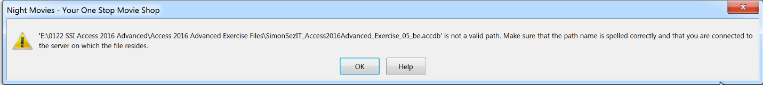

This message does not indicate that an error has occurred. The situation that causes this message to be displayed is normal, and this almost always happens when you copy split Access databases from our website to your computer. This is almost unavoidable.

It is straightforward to resolve the issue that gives rise to the message. If you see a message like this one you need to use the Access 2019 Linked Table Manager to re-link the table definitions in the “front end” database to the actual tables in the “back end” database on you own computer.

To do this, make sure that you have the “back end” database in position first (having copied it from our website), then open the relevant “front end” database and follow the procedure that is explained and demonstrated in *Chapter 6 Splitting an Access database – Part 2*. The explanation starts at about 8 minutes and 50 seconds, at the start of the 4th numbered part of the video.

For more explanation of linking tables in separate Access databases using the Linked Table Manager, please also refer to the video for *Chapter 4 Linking to other Access databases*.